Software Requirements Specification
For
Online Food Ordering System
Version 1.0 approved
Prepared by Summiya Zulfiqar (EP-1851048)
Aamir Bashir (EP-1851001)
MCS Final DBMS Project
Table of Contents
Table of Contents 1
1. Introduction 2
1.1 Purpose 2
1.2 Product Scope 2
1.3 Overview 2
2. Overall Description 3
2.1 Product Perspective 3
2.2 Product Functions 3
2.3 User Classes and Characteristics 4
2.4 Design and Implementation Constraints 4
4. System Features 4
5. Other Nonfunctional Requirements 5
5.1 Performance Requirements 5
5.2 Safety Requirements 5
5.3 Security Requirements 5
6. UML Analysis Model 6
5.1 Context DFD 6
5.2 1st Level DFD 6
5.3 2nd Level DFD 7
5.4 Admin Side DFD 7
5.5 ERD 8

Introduction
The following section provides an overview of the derived Software Requirements Specification (SRS) for the subject Online Food Ordering System (OOS). To begin with, the purpose of the document is presented and its intended audience outlined. Subsequently, the scope of the project specified by the document is given with a particular focus on what the resultant software will do and the relevant benefits associated with it. The nomenclature used throughout the SRS is also offered. To conclude, a complete document overview is provided to facilitate increased reader comprehension and navigation.

Purpose
The purpose of this SRS is to outline both the functional and non-functional requirements of the subject OOS. In addition to said requirements, the document also provides a detailed profile of the external interfaces, performance considerations and design constraints imposed on the subsequent implementation. It is the intention that the presented set of requirements possesses the following qualities; correctness, unambiguousness, completeness, consistency, verifiability, modifiability and traceability. Consequently, the document should act as a foundation for efficient and well-managed project completion and further serve as an accurate reference in the future. The primary audience of this SRS document will be the development team employed to implement the specified RMOS. It will not only provide an extensive capacity for project planning and progress assessment but it will further assist with developer/stakeholder interactions. The secondary document audience comprises the stakeholders of the project, that is, restaurateurs and associated staff. To this audience group, this SRS should convey and confirm the required functionality and represent a contractual agreement between the involved parties.

Product Scope
In current formal dining environments, some form of physical static menu is utilized to convey the available food and beverage choices to customers. Said menus are generally paper based and hence impose restrictions on the textual real estate available and the ability a restaurateur has to update them. This document specifies the requirements for a restaurant paper menu and ordering replacement strategy to alleviate the problems associated with the current archaic method. Three related concepts are encompassed by the general scope of the Restaurant Menu and Ordering System. The first pertains to the replacement of paper-based menus using an electronic format, the second relates to a complementary electronic strategy for the front of house handling of a customer’s order and the third surrounds the process of transferring said electronic orders to the kitchen for preparation. It should be noted that while the suggested strategy incorporates the use of various hardware components, the primary focus of the presented SRS relates to the constituent software elements.

Overview
The Restaurant Menu and Ordering System is a web-based system to facilitate customers to place their order and supply necessary details. The customer is able to view the menu, place orders and organize the final bill. Order Manager is able to view and confirm order. The food staff, with their web-display interfaces, are able to view confirmed orders sent to the kitchen by Manager. The system contains full accountability and logging systems, and supports supervisor actions to account for exceptional circumstances, such as a meal being refunded or walked out on. Customers are presented with an attractive and easy-to-use surface computer GUI with a drag-and drop ‘object’ metaphor in their menus. Managers are able to perform all actions that the order is delivered or cancelled.

Overall Description
The following section presents an overall description of the subject OOS. In particular, the product has been put into perspective through a detailed assessment of the system, user, hardware, software and communication interfaces, memory considerations, operational modes and site adaptation requirements. Further, characteristics of the system’s end-users are discussed along with the identified system constraints and assumptions. To conclude the section, an apportioning of requirements has been outlined.

Product Perspective
The software described in this SRS is the software for a complete OOS system. The system merges various hardware and software elements and further interfaces with external systems. Thus, while the software covers the majority of the system's functionality, it relies on a number of external interfaces for persistence and unhandled tasks, as well as physically interfacing with humans. The Online Food Order System application is a web-based system. It can be accessed using any browser.

Product Functions
The Online Food Order System application would have the following basic functions:

Web Ordering System Module:
This module provides the functionality for customers to place their order and supply necessary details. Users of the system, namely restaurant customers, must be provided the following functionality:
• Create an account.
• Manage their account.
• Log in to the system.
• Navigate the restaurant’s menu.
• Select an item from the menu.
• Add an item to their current order.
• Review their current order.
• Remove an item/remove all items from their current order.
• View Bill details.
• Place an order.
• Receive confirmation in the form of an order number.
• View order placed.

Menu Management System Module
This module provides functionality for the power user-Administrator only. It will not be available to any other users of the system like Restaurant Employees or Customers. Using a graphical interface, it will allow an Admin to manage the menu that is displayed to users of the web ordering system:
• Add/update/delete food category to/from the menu.
• Add /update/delete food item to/from the menu.
• Update price for a given food item.
• Update additional information (description, photo, etc.) for a given food item.
Before customers can actually use this system, functionality provided by this component will have to be configured first. Once the initial configuration is done, this will be the least likely used component as menu updates are mostly seasonal and do not occur frequently.
Order Retrieval System Module
This is the simplest module out of all 3 modules. It is designed to be used only by restaurant employees, and provides the following functions:
• Retrieve new orders from the database.
• Display the orders in an easily readable, graphical way.
• Mark done when an order is delivered.

User Classes and Characteristics
The end-users of the OOS fall into three primary categories, unskilled, partly skilled and highly skilled.
Unskilled user
The customers should be assumed to have no relevant prior skills or education other than basic abilities to place their order using web portal.
Partly skilled user
The restaurant employee’s waiters and chefs should be able to use the system and further be able to train others with minimal training themselves. They must be able to view pending orders and mark completed. Supervisors also fall into the same category, though they will have to learn other sections of the system (refunds etc.).
Highly skilled user
The initial installation and configuration of hardware and the constituent OOS system components (especially the server) is guaranteed to require someone with notable computer experience, including extensive experience with network and operating systems to complete it. The software should not be needlessly complex, but it is still expected not to be entirely 'plug and play'. This class of user is expected to have a high-school certificate or equivalent, as well as extensive computer experience.

Design and Implementation Constraints
Hardware/Software Interface:
This section lists the minimum hardware and software requirements needed to run the system efficiently. Hardware Interface:
• Pentium Processor
• 60 MB of free hard-drive space
• 128 MB of RAM
Software Interface:
• Operating System: Windows (Vista/7 or above)
• Web Browser: IE 10 or above, Mozilla FF 31 and above or Google Chrome

System Features

Online Order
The application will allow user to place order online. This will allow the customers to select their favorite items from menu and order.

Customer Feedback
Customer can enter the feedback about the service and the food served. This helps the Restaurant owner to analyze the service and make necessary changes if needed. This also helps the Customer’s to decide a particular food item with a positive feedback.

Click-n-Add Menu
Customer can search a particular food item according to category from menu. The customer just has to click on food item and it will be added to his list. This saves a lot of time of customer to order an item.

Offers for Customer
The Restaurant owner can post various offers in menu. This will help the customer as well as the restaurant owners.

Attractive Profile
There are images of every food item and restaurant location which will make the view of customers more clearly about how the food will look like after delivery.

Time to deliver
The manager gets the approximate time customer can view delivery tie time while ordering. Food deliver according to approximate time. Provides ease to customers.

Other Nonfunctional Requirements

Performance Requirements
The server shall be capable of supporting an arbitrary number of active meals/orders and number of active customer payments, that is, no meals/orders and payments shall be lost under any circumstances.

Safety Requirements
The system shall be capable of restoring itself to its previous state in the event of failure and can be installed and run under most operating systems.

Security Requirements
System should be password protected (can also be encrypted) .The system shall provide User level access to system functionality. Placing Order shall require a user to log in using a username and password but display shall not require a user to log in.

UML ANALYSIS MODELS

Context level DFD for Online food system

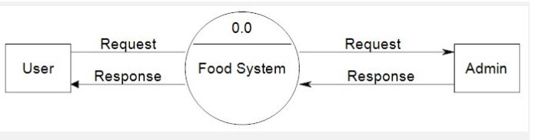

1st level DFD for User
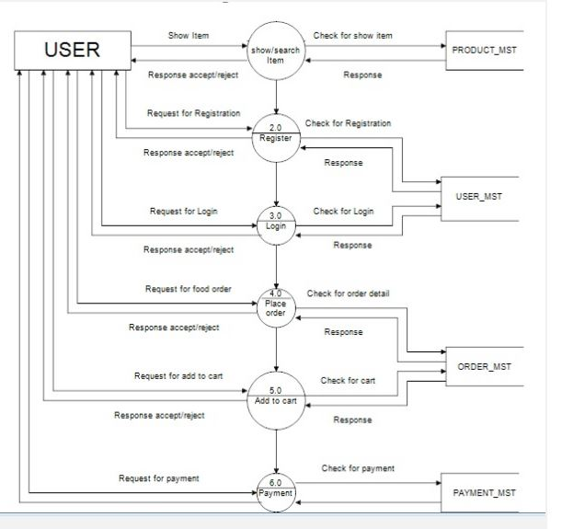

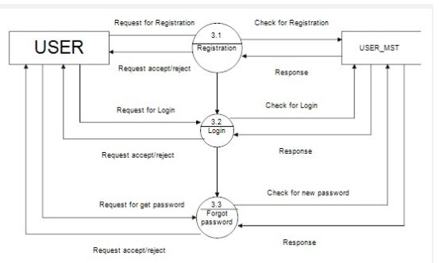
2nd level DFD for user (3.0)

Admin side DFD for online food system
